**Introduction to Javascript**

**12th February 2019**

**\* Prompt for amount, interest rate and no. of years and calculate simple interest.**

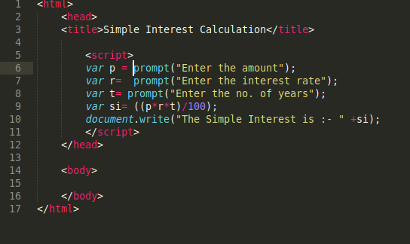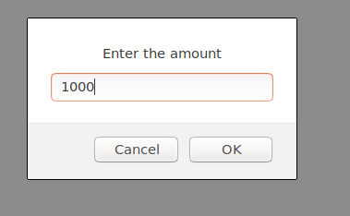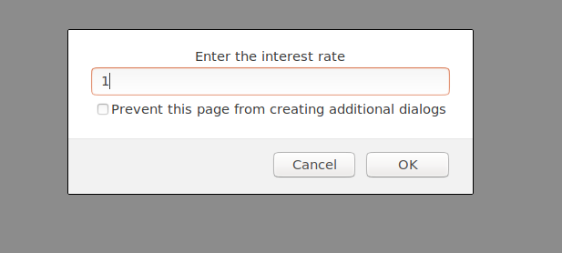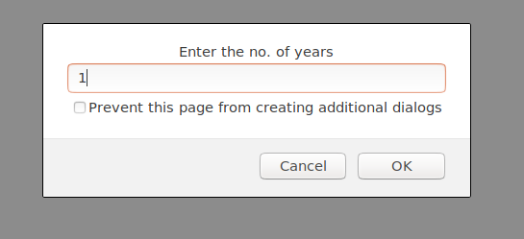

Here we used prompt for amount , interest and time so that we can calculate the simple interest and then we used the formula of simple interest and then by using document.write we printed the calculated simple interest.

**\* Is palindrome string.**

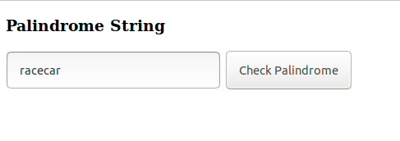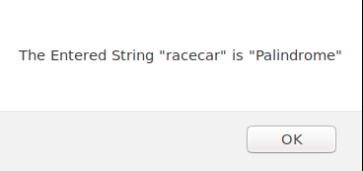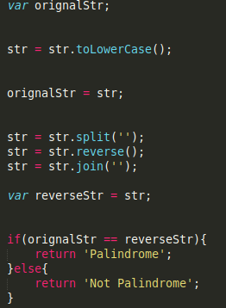

Here first we lowercase the entered string then we stored the string to original string . After that we split the string and then reverse the order and then we joined the reverse order values and the entered string is reversed. After that we finally check both the strings stored in original string and reversed to find the palindrome if true the palindrome is returned.

**\* Area of circle.**

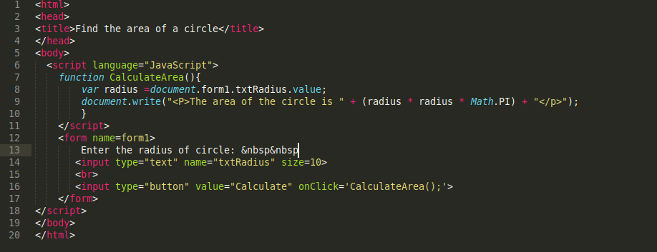

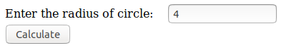



Here under the script tag we created a function Calculate area and after the function we used var radius and then in document.write we concatenated the text with the area of circle. While using a form tag we created a text area so that we can enter radius along with a button which when clicked will show the area of the circle according to the radius entered.

**\* Copy information of one object to another and log it to console.**

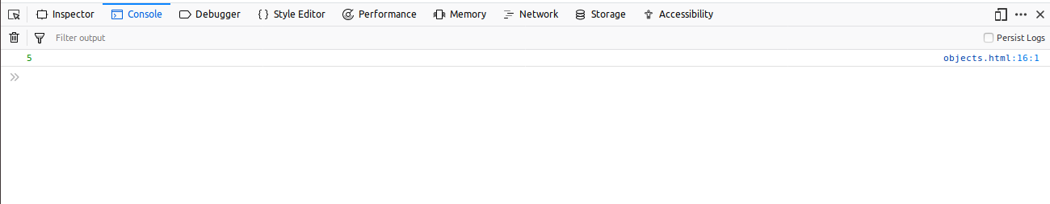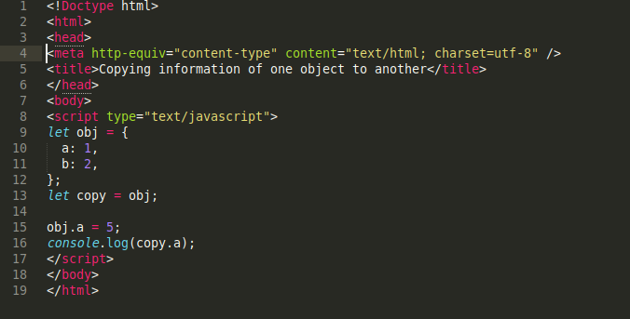

Here by using let we created an object with name obj and then we added some information to it. After that we made a new object name copy and then we copied the information of obj to copy such that when we make changes in the obj then changed value will automatically be shown in the other object.

**\* Create a list of objects of Employee with info as follow :**

**Name, age, salary ,DOB**

**Filter all employees with salary greater than 5000**

**Group employee on the basis of their age**

**Fetch employees with salary less than 1000 and age greater than 20 Then give them an increment 5 times their salary.**

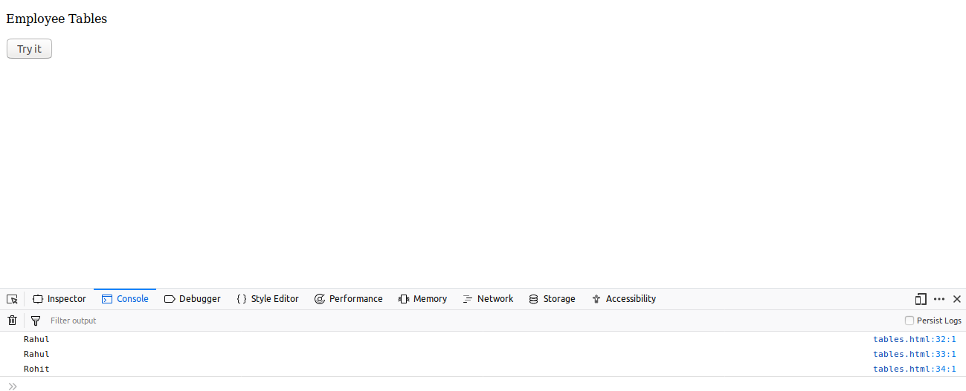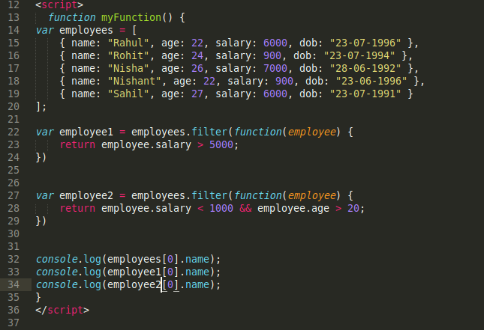

Here in this case first we created a list of employees with name,age,salary and DOB inside the main function that is myFunction().Then as per the requirement we were able to categorized the employees with salary greater than 5000, employees with salary less than 1000 but age more than 20.